There is no better, more easily understood, and more fun explanation of the complexity of markets than Leonard Read’s “I, Pencil.” It ought to give considerable pause when we listen to the arrogance of politicians who tell us they can manage an economy better than millions, perhaps billions, of independent decision makers in pursuit of their own goals. Its message to would-be planners is to bug out!

WALTER E. WILLIAMS
PROFESSOR OF ECONOMICS • GEORGE MASON UNIVERSITY

“I, Pencil” is a superb case study of free markets in action. Half of the world’s economic problems would vanish if everyone would read “I, Pencil.”

BURTON W. FOLSOM
PROFESSOR OF HISTORY • HILLSDALE COLLEGE

What have economists contributed to human knowledge? Plenty, but the magical, beautiful idea of the division of labor might rank as the most important insight. “I, Pencil” explains we create so much more wealth as a community than we ever could alone - in fact, even the simplest item cannot be made without a complex division of labor.

JEFFREY A. TUCKER
DIRECTOR OF DIGITAL DEVELOPMENT • FEE

“I, Pencil” provides remarkable insights into the complexity generated by market mechanisms. Textbook economics almost never incorporates these insights.

MICHAEL STRONG CO-FOUNDER • CONSCIOUS CAPITALISM CEO • RADICAL SOCIAL ENTREPRENEURS

FEE’s mission is to inspire, educate, and connect future leaders with the economic, ethical, and legal principles of a free society.

Join us online at: FEE.org
Facebook.com/FEEonline Twitter.com/FEEonline (@feeonline)

Foundation for Economic Education
1819 Peachtree Road NE, Suite 300
Atlanta, Georgia 30309
Telephone: (404) 554-9980

Print ISBN: 978-1-57246-043-0
Ebook ISBN: 978-1-57246-042-3

Published under the Creative Commons Attribution 4.0 International License.

First printing: May 2015 Second printing: May 2016

Cover design by Crowdskout Print layout design by Lauren Hicks
We invite you to advance liberty with us.
visit FEE.org

My Family Tree as Told to
Leonard E. Read

This printing was made possible through the generosity of The Ralph Smeed Private Memorial Foundation.

Introduction

BY LAWRENCE W. REED

Eloquent. Extraordinary. Timeless. Paradigm-shifting. Classic. Six decades after it first appeared, Leonard Read’s “I, Pencil” still evokes such adjectives of praise. Rightfully so, for this little essay opens eyes and minds among people of all ages. Many first-time readers never see the world quite the same again.
Ideas are most powerful when they’re wrapped in a compelling story. Leonard’s main point—economies can hardly be “planned” when not one soul possesses all the know-how and skills to produce a simple pencil—unfolds in the enchanting words of a pencil itself. Leonard could have written “I, Car” or “I, Airplane,” but choosing those more complex items would have muted the message. No one person—repeat, no one, no matter how smart or how many degrees follow his name—could create from scratch a small, everyday pencil, let alone a car or an airplane. This is a message that humbles the high and mighty. It pricks the inflated egos of those who think they know how to mind everybody else’s business. It explains in plain language why central planning is an exercise in arrogance and futility, or what Nobel laureate and Austrian economist F. A. Hayek aptly termed
“the pretence of knowledge.”
Indeed, a major influence on Read’s thinking in this regard was Hayek’s famous 1945 article, “The Use of Knowledge in Society.” In demolishing the spurious claims of the socialists of the day, Hayek wrote, “This is not a dispute about whether planning is to be done or not. It is a dispute as to whether planning is to be done centrally, by one authority for the whole economic system, or is to be divided among many individuals.”
Maximilien Robespierre is said to have blessed the horrific French Revolution with this chilling declaration: “On ne saurait pas faire une omelette sans casser des oeufs.” Translation: “One can’t expect to make an omelet without breaking eggs.”

A consummate statist who worked tirelessly to plan the lives of others, he would become the architect of the Revolution’s bloodiest phase—the Reign of Terror of 1793–94.
Robespierre and his guillotine broke eggs by the thousands in a vain effort to impose a utopian society with government planners at the top and everybody else at the bottom. That French experience is but one example in a disturbingly familiar pattern. Call them what you will—socialists, interventionists, collectivists, statists—history is littered with their presumptuous plans for rearranging society to fit their vision of the common good, plans that always fail as they kill or impoverish other people in the process. If socialism ever earns a final epitaph, it will be this: Here lies a contrivance engineered by know-it-alls who broke eggs with abandon but never, ever created an omelet.
None of the Robespierres of the world knew how to make a pencil, yet they wanted to remake entire societies. How utterly preposterous, and mournfully tragic! But we will miss a large implication of Leonard Read’s message if we assume it aims only at the tyrants whose names we all know. The lesson of “I, Pencil” is not that error begins when

the planners plan big. It begins the moment one tosses humility aside, assumes he knows the unknowable, and employs the force of the State against peaceful individuals. That’s not just a national disease. It can be very local indeed.
In our midst are people who think that if only they had government power on their side,

In our midst are people who think that if only they had government power on their side, they could pick tomorrow’s winners and losers...

they could picktomorrow’s winnersand losersinthemarketplace, set prices or rents where they ought to be, decide which forms of energy should power our homes and cars, and choose which industries should survive and which should die. They should stop for a few moments and learn a little humility from a lowly writing implement.

While “I, Pencil” shoots down the baseless expectations for central planning, it provides a supremely uplifting perspective of the individual. Guided by Adam Smith’s “invisible hand” of prices, property, profits, and incentives, free people accomplish economic miracles of which socialist theoreticians can only dream. As the interests of countless individuals from around the world converge to produce pencils without a single “master mind,” so do they also come together in free markets to feed, clothe, house, educate, and entertain hundreds of millions of people at ever higher levels.
With great pride, FEE publishes this new edition of “I, Pencil” to mark the essay’s timeless message for a new generation. Someday there will be a centennial edition, maybe even a millennial one. This essay is truly one for the ages.

- Lawrence W. Reed
President, FEE Atlanta, Georgia
May 2015

I, Pencil

My Family Tree as told to Leonard E. Read

I am a lead pencil—the ordinary wooden pencil familiar to all boys and girls and adults who can read and write.
Writing is both my vocation and my avocation; that’s all I do. You may wonder why I should write a genealogy. Well, to begin with, my story is interesting. And, next, I am a mystery
—more so than a tree or a sunset or even a flash of lightning. But, sadly, I am taken for granted by those who use me, as if I were a mere incident and without background. This supercilious attitude relegates me to the level of the commonplace. This is a species of the grievous error in which mankind cannot too long persist without peril. For, the wise G. K. Chesterton observed, “We are perishing for want of wonder, not for want of wonders.”
I, Pencil, simple though I appear to be, merit your wonder and awe, a claim I shall attempt to prove. In fact, if you can understand
me—no, that’s too much to ask of anyone—if you can become

aware of the miraculousness which I symbolize, you can help save the freedom mankind is so unhappily losing. I have a profound lesson to teach. And I can teach this lesson better than can an automobile oran airplane or a mechanical dishwasher because—well, because I am seemingly so simple.
Simple? Yet, not a single person on the face of this

If you can become aware of the miraculousness which I symbolize, you can help
save the freedome mankind is so unhappily losing.
“

earth knows how to make me. This sounds fantastic, doesn’t it? Especially when it is realized that there are about one and one- half billion of my kind produced in the U.S.A. each year.
Pick me up and look me over. What do you see? Not much

meets the eye—there’s some wood, lacquer, the printed labeling, graphite lead, a bit of metal, and an eraser.

INNUMERABLE ANTECEDENTS

Just as you cannot trace your family tree back very far, so is it impossible for me to name and explain all my antecedents. But I would like to suggest enough of them to impress upon you the richness and complexity of my background.
My family tree begins with what in fact is a tree, a cedar of straight grain that grows in Northern California and Oregon. Now contemplate all the saws and trucks and rope and the countless other gear used in harvesting and carting the cedar logs to the railroad siding. Think of all the persons and the numberless skills that went into their fabrication: the mining of ore, the making of steel and its refinement into saws, axes, motors; the growing of hemp and bringing it through all the stages to heavy and strong rope; the logging camps with their beds and mess halls, the cookery and the raising of all the foods. Why, untold thousands of persons had a hand in every cup of coffee the loggers drink!
The logs are shipped to a mill in San Leandro, California. Can you imagine the individuals who make flat cars and rails and railroad engines and who construct and install the communication systems incidental thereto? These legions are among my antecedents.
Consider the millwork in San Leandro. The cedar logs are cut into small, pencil-length slats less than one-fourth of an inch in thickness. These are kiln dried and then tinted for the same reason women put rouge on their faces. People prefer that I look pretty, not a pallid white. The slats are waxed and kiln dried again. How many skills went into the making of the tint and the kilns, into supplying the heat, the light and power, the belts, motors, and all the other things a mill requires? Sweepers in the mill among my ancestors? Yes, and included are the men who poured the concrete for the dam of a Pacific Gas & Electric Company hydroplant which supplies the mill’s power!
Don’t overlook the ancestors present and distant who have a

hand in transporting sixty carloads of slats across the nation.
Once in the pencil factory—$4,000,000 in machinery and building, all capital accumulated by thrifty and saving parents of mine—each slat is given eight grooves by a complex machine, after which another machine lays leads in every other slat, applies glue, and places another slat atop—a lead sandwich, so to speak. Seven brothers and I are mechanically carved from this “wood- clinched” sandwich.
My “lead” itself—it contains no lead at all—is complex. The graphite is mined in Ceylon [Sri Lanka]. Consider these miners and those who make their many tools and the makers of the paper sacks in which the graphite is shipped and those who make the string that ties the sacks and those who put them aboard ships and those who make the ships. Even the lighthouse keepers along the way assisted in my birth—and the harbor pilots.
The graphite is mixed with clay from Mississippi in which ammonium hydroxide is used in the refining process. Then wetting agents are added such as
sulfonated tallow—animal fats

chemically reacted with sulfuric acid. After passing through numerous machines, the mixture finally appears as endless extrusions—as from a sausage grinder—cut to size, dried, and baked for several hours at 1,850 degrees Fahrenheit. To increase their strength and smoothness the leads are then treated with a hot mixture which includes

Why, even the processes by which the lacquer is made a beautiful yellow involve the skills of more persons
than one can enumerate.

candelilla wax from Mexico, paraffin wax, and hydrogenated natural fats.
My cedar receives six coats of lacquer. Do you know all the ingredients of lacquer? Who would think that the growers of castor beans and the refiners of castor oil are a part of it? They are.
Observe the labeling. That’s a film formed by applying heat

to carbon black mixed with resins. How do you make resins and what, pray, is carbon black? Why, even the processes by which the lacquer is made a beautiful yellow involve the skills of more persons than one can enumerate!
My bit of metal—the ferrule—is brass. Think of all the persons who mine zinc and copper and those who have the skills to make shiny sheet brass from these products of nature. Those black rings on my ferrule are black nickel. What is black nickel and how is it applied? The complete story of why the center of my ferrule has no black nickel on it would take pages to explain.
Then there’s my crowning glory, inelegantly referred to in the trade as “the plug,” the part man uses to erase the errors he makes with me. An ingredient called “factice” is what does the erasing. It is a rubber-like product made by reacting rapeseed oil from the Dutch East Indies [Indonesia] with sulfur chloride. Rubber, contrary to the common notion, is only for binding purposes. Then, too, there are numerous vulcanizing and accelerating agents. The pumice comes from Italy; and the pigment which gives “the plug” its color is cadmium sulfide.

NO ONE KNOWS
“

Does anyone wish to challenge my earlier assertion that no single person on the face

Actually,

of this earth knows how to make me?
Actually, millions of human beings have had a hand in my creation, no one of whom even knows more than a very few of the others. Now, you may say that I go too far in relating the picker of a coffee berry in far-off

millions of human beings have had a hand in my creation, no one of whom even knows more than a very few of
the others.

Brazil and food growers elsewhere to my creation; that this is an extreme position. I shall stand by my claim. There isn’t a single person in all these millions, including the president of the pencil

company, who contributes more than a tiny, infinitesimal bit of know-how. From the standpoint of know-how the only difference between the miner of graphite in Ceylon and the logger in Oregon is in the type of know-how. Neither the miner nor the logger can be dispensed with, any more than can the chemist at the factory or the worker in the oil field—paraffin being a by-product of petroleum.
Here is an astounding fact: Neither the worker in the oil field nor the chemist nor the digger of graphite or clay nor any who mans or makes the ships or trains or trucks nor the one who runs the machine that does the knurling on my bit of metal nor the president of the company performs his singular task because he wants me. Each one wants me less, perhaps, than does a child in the first grade. Indeed, there are some among this vast multitude who never saw a pencil nor would they know how to use one. Their motivation is other than me. Perhaps it is something like this: Each of these millions sees that he can thus exchange his tiny know-how for the goods and services he needs or wants. I may or may not be among these items.

NO MASTER MIND

There is a fact still more astounding: The absence of a master mind, of anyone dictating or forcibly directing these countless actions which bring me into being. No trace of such a person can be found. Instead, we find the Invisible Hand at work. This is the mystery to which I earlier referred.
It has been said that “only God can make a tree.” Why do we agree with this? Isn’t it because we realize that we ourselves could not make one? Indeed, can we even describe a tree? We cannot, except in superficial terms. We can say, for instance, that a certain molecular configuration manifests itself as a tree. But what mind is there among men that could even record, let alone direct, the constant changes in molecules that transpire in the life span of a tree? Such a feat is utterly unthinkable!
I, Pencil, am a complex combination of miracles: a tree, zinc, copper, graphite, and so on. But to these miracles which

manifest themselves in Nature an even more extraordinary miracle has been added: the configuration of creative human energies—millions of tiny know-hows configurating naturally and spontaneously in response to human necessity and desire and in the absence of any human masterminding! Since only God can make a tree, I insist that only God could make me. Man can no more direct these millions of know-hows to bring me into being than he can put molecules together to create a tree.
The above is what I meant when writing, “If you can become aware of the miraculousness which I symbolize, you can help save the freedom mankind is so unhappily losing.” For, if one is aware that these know-hows will naturally, yes, automatically, arrange themselves into creative and productive patterns in response to human necessity and demand— that is, in the absence of governmental or any other coercive master-minding—then one will possess an absolutely essential ingredient for freedom: a faith in free people. Freedom is impossible without this faith.
Once government has had a monopoly of a creative activity such, for instance, as the delivery of the mails, most individuals will believe that the mails could not be efficiently delivered by men acting freely. And here is the reason: Each one acknowledges that he himself doesn’t know how to do all the things incident to mail delivery. He also recognizes that no other individual could do it. These assumptions are correct. No individual possesses enough know-how to perform a nation’s mail delivery any more than any individual possesses enough know-how to make a pencil. Now, in the absence of faith in free people—in the unawareness that millions of tiny know-hows would naturally and miraculously form and cooperate to satisfy this necessity—the individual cannot help but reach the erroneous conclusion that mail can be delivered only by governmental “masterminding.”

TESTIMONY GALORE

If I, Pencil, were the only item that could offer testimony on what men and women can accomplish when free to try, then those with little faith would have a fair case. However, there is

testimony galore; it’s all about us and on every hand. Mail delivery is exceedingly simple when compared, for instance, to the making of an automobile or a calculating machine or a grain combine or a milling machine or to tens of thousands of other things. Delivery? Why, in this area where men have been left free to try, they deliver
the human voice around the world in

The lesson I have to teach is this: Leave all creative energies uninhibited.
less than one second; they deliver an event visually and in motion to any person’s home when it is happening; they deliver 150 passengers from Seattle to Baltimore in less than four hours; they deliver gas from Texas to one’s range or furnace in New York at unbelievably low rates and without subsidy; they deliver each four pounds of oil from the Persian

Gulf to our Eastern Seaboard—halfway around the world—for less money than the government charges for delivering a one- ounce letter across the street!
The lesson I have to teach is this: Leave all creative energies uninhibited. Merely organize society to act in harmony with this lesson. Let society’s legal apparatus remove all obstacles the best it can. Permit these creative know-hows freely to flow. Have faith that free men and women will respond to the Invisible Hand. This faith will be confirmed. I, Pencil, seemingly simple though I am, offer the miracle of my creation as testimony that this is a practical faith, as practical as the sun, the rain, a cedar tree, the good earth.

Leonard E. Read
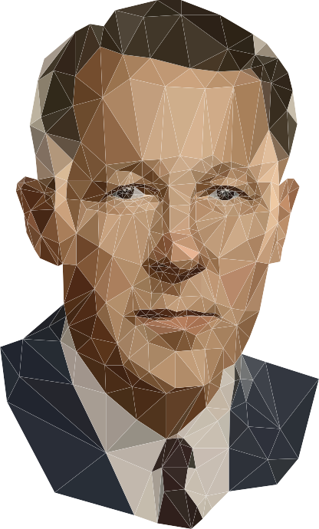
Leonard E. Read (1898-1983) established the Foundation for Economic Education in 1946. For the next 37 years he served as FEE’s president and labored tirelessly to promote and advance liberty. He was a natural leader who, at a crucial moment in American history, roused the forces defending individual freedom and private property.
His life is a testament to the power of ideas. As President Ronald Reagan wrote: “Our nation and her people have been vastly enriched by his devotion to the cause of freedom, and generations to come will look to Leonard Read for inspiration.”
Read was the author of 29 books and hundreds of essays. “I, Pencil,” his most famous essay, was first published in 1958. Although a few of the manufacturing details and place names have changed, the principles endure.

CONTINUE THE CONVERSATION
ONLINE & ON-CAMPUS

FEEonline @FEEonline FEEonline FEEseminars FEE.org/magazine

eBooks
Now available for
FREE download at FEE.org/eBooks

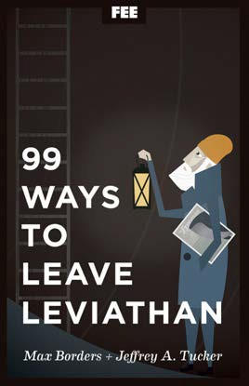
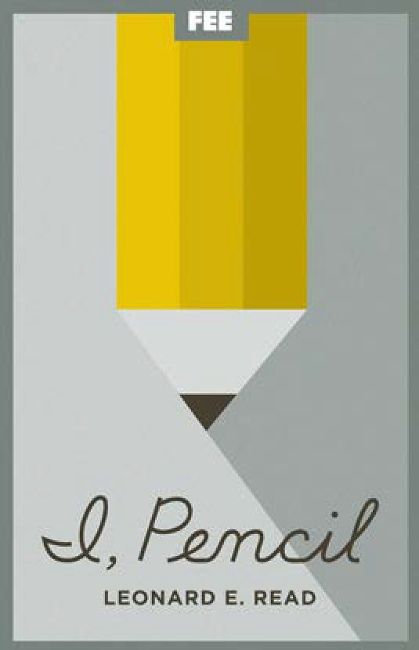
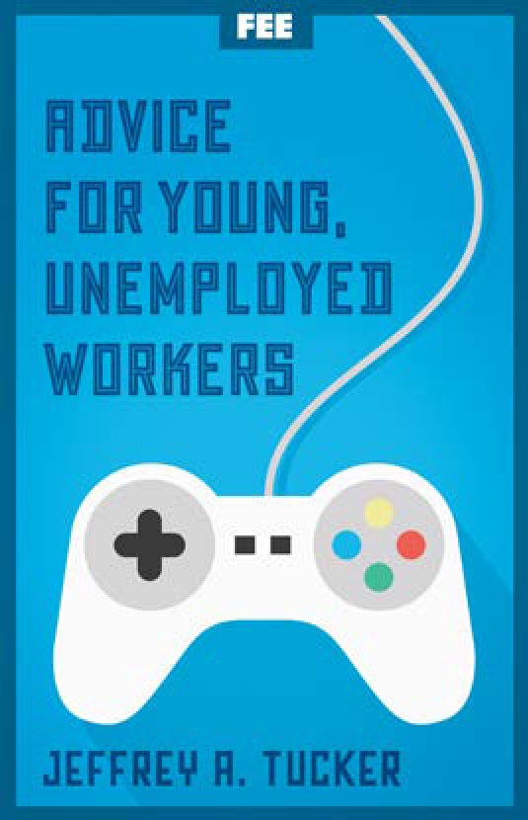
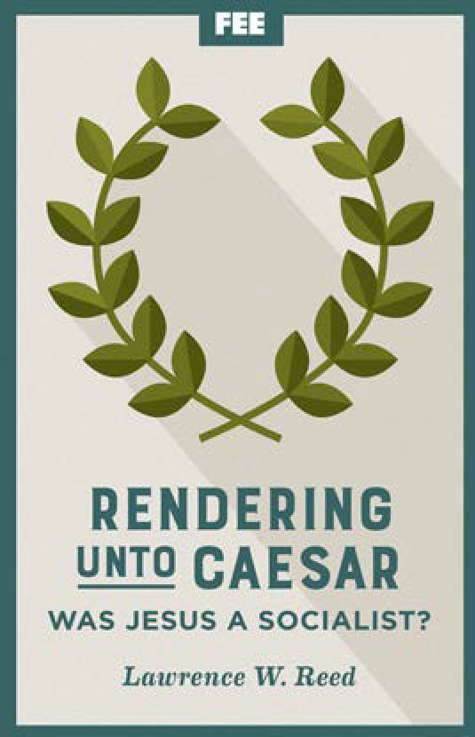

WE INVITE YOU TO ADVANCE LIBERTY
WITH US.

The Foundation for Economic Education is the premier source for understanding the humane values of a free society, and the economic, legal, and ethical principles that make it possible. At FEE, students and their mentors explore freedom’s limitless possibilities through seminars, classroom resources, social media, daily content, and free online courses,
all available at FEE.org.

FEE.ORG |

The Foundation for Economic Education (FEE) is the premier source for understanding the humane values of a free society, and the economic, legal, and ethical principles that make it possible. At FEE, you’ll be connected with people worldwide who share those values and are inspired by the dynamic ideas of free association, free markets, and a diverse civil society.

Explore freedom’s limitless possibilities through seminars, classroom resources, social media, free online courses, and exciting daily content at FEE.org. Learn how your creativity and initiative can result in a prosperous and flourishing life for yourself and the global community. Whether you are just beginning to explore entrepreneurship, economics, or creating value for others or are mentoring others on their journeys, FEE has everything you need.

FEE is supported by voluntary, tax-deductible contributions fromindividuals, foundations, andbusinesseswho believethat it is vital to cultivate a deep appreciation in every generation for individual liberty, personal character, and a free economy. Supporters receive a subscription to our flagship magazine, the Freeman, also available at FEE.org.

WE INVITE YOU TO ADVANCE LIBERTY WITH US. | VISIT FEE.ORG

